Ideation Phase
Empathize & Discover

Date | 08 December 2025
Team ID
Project Name | Book Store
Maximum Marks | 4 Marks

Empathy Map Canvas:
Understand the needs, frustrations, and behaviors of BookStore Users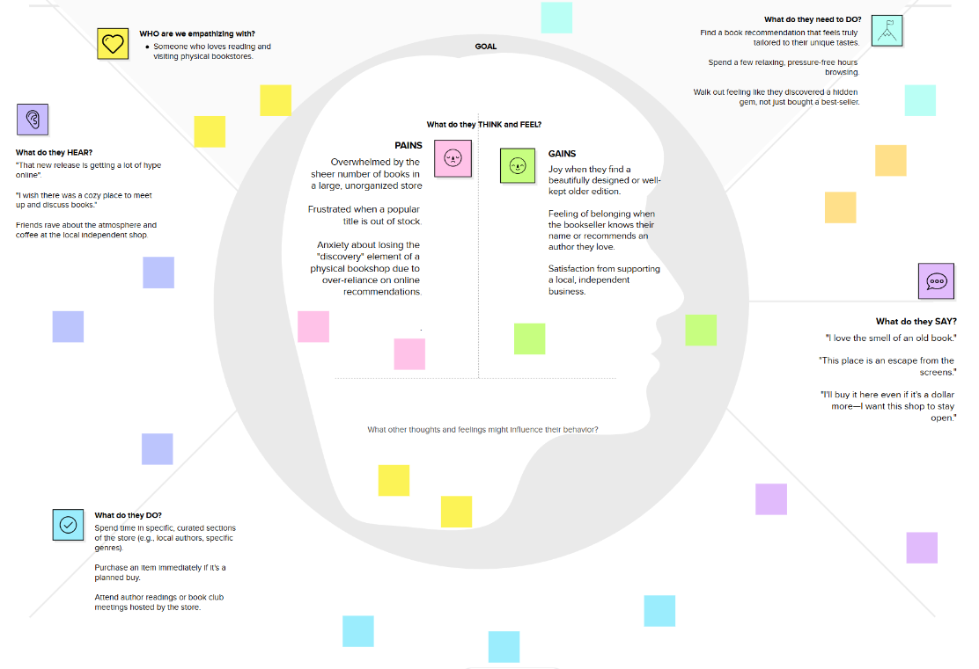

seeking consistent work through a platform like Book Store.

